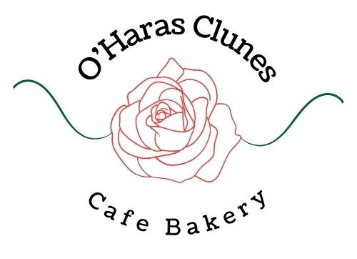
Clunes Primary School
Term 2 Lunch Orders Mondays
Orders must be placed Online by 7pm on the Friday prior.
Choose 1 main and 1 dessert option.

Gluten free options available. Please message us prior to ordering for any dietary requirements – oharasbakery@outlook.com
Week | Date | Menu | Payment link
1 | 20th April | No lunch orders
2 | 27th April | Main: Hotdog or Sausage Roll or Plain Pie or Salad Roll  Dessert: Jelly Cup or Chocolate Freckles or Apple Juice or Water | Order here  Orders Close 24th April
3 | 4th May | Main: Chicken pasta bake or Sausage Roll or Plain Pie or  Salad Roll  Dessert: Jelly Cup or Chocolate Freckles or Apple Juice or Water | Order here  Orders Close 1st May
4 | 11th May | Main: Lasagna or Sausage Roll or Plain Pie or Salad Roll  Dessert: Jelly Cup or Chocolate Freckles or Apple Juice or Water | Order here  Orders Close 8th May
5 | 18th May | Main: Hotdog or Sausage Roll or Plain Pie or Salad Roll  Dessert: Jelly Cup or Chocolate Freckles or Apple Juice or Water | Order here  Orders Close 15th May
6 | 25th May | Main: Chicken pasta bake or Sausage Roll or Plain Pie or  Salad Roll  Dessert: Jelly Cup or Chocolate Freckles or Apple Juice or Water | Order here  Orders Close 22nd May
7 | 1st June | Main: Lasagna or Sausage Roll or Plain Pie or Salad Roll  Dessert: Jelly Cup or Chocolate Freckles or Apple Juice or Water | Order here  Orders Close 29th May
8 | 8th June | No Lunch orders  Kings Birthday Public Holiday
9 | 15th June | Main: Hotdog or Sausage Roll or Plain Pie or Salad Roll  Dessert: Jelly Cup or Chocolate Freckles or Apple Juice or Water | Order here  Orders Close 12th June
10 | 22nd June | Main: Lasagna or Sausage Roll or Plain Pie or Salad Roll  Dessert: Iced Donut, Jelly Cup or Chocolate Freckles or Apple Juice or Water | Order here  Orders Close 19th June

